NAME: YATHISH D M

Register Number : 211039014

1 . Program for adding nibble4 &nibble0

AREA ASMPROGRAM, CODE, READONLY

ENTRY

MAIN

LDR R0,VALUE;LOADING THE VALUE TO R0

LDR R1, [R0] ;loading to R1

LDR R2, [R0] ; loading value into R2

AND R2, #0x000F000 ;fourth nibble is masking to R2

AND R1, #0X000000F ;Oth nibble is masking to R1

LSL R1, #16 ;shifting R1 to fourth nibble for addition

ADD R1, R2 ; adding r1 and r2

LDR R0, RESULT;

STR R1, [R0];

VALUE DCD 0X40000004

RESULT DCD 0X4000000C

END

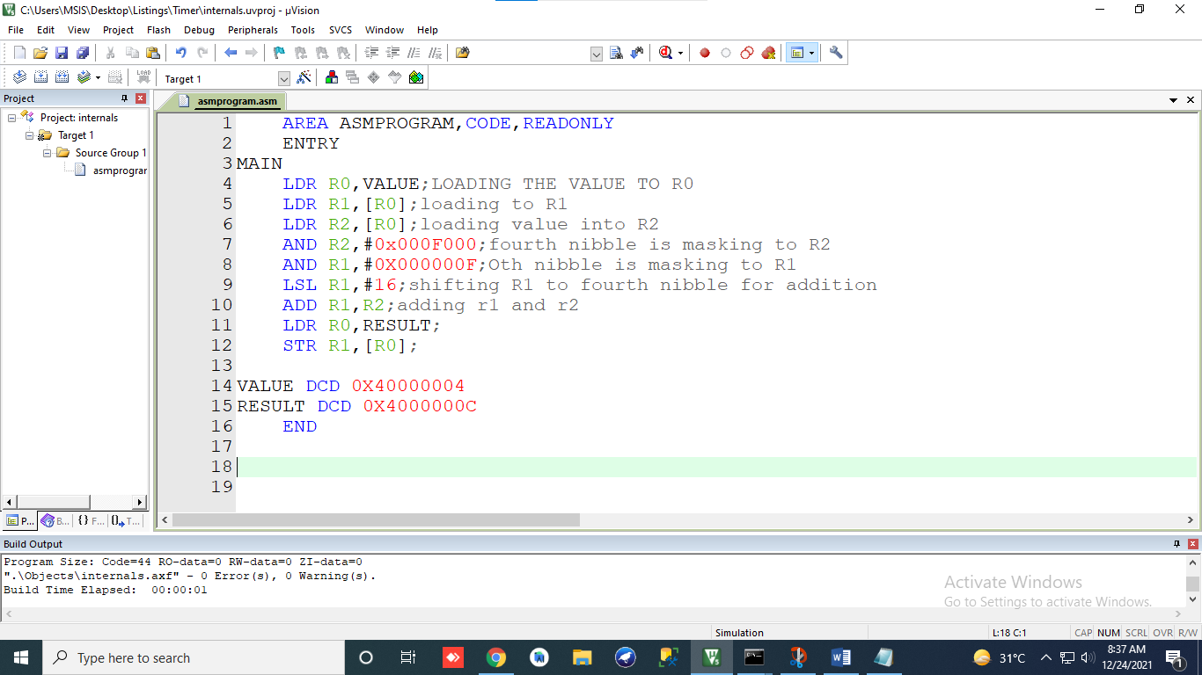

2.Array program

AREA ARRAY,CODE,READONLY

ENTRY

MAIN

LDR R0,[R1];loading address to R0

LDR R3,COUNT ;loading address of the count into

;LDR R5,RESULT

LDR R4,[R3]

LOOP

LDR R1, [R0] ; loading content of address which is in R0 into R1

CMP R1, #0 ; comparing content of R1 to 0 to check for negative number

BMI JUMP;if the number in R1 is negative goto jump

ADD R2,R1;else add R2 and R1 and stores in R2

ADD R0,#4;incrementing the address in R0 to fetch next element of array

ADD R4,#-1;decrementing counter

CMP R4,#0;checks if R4 thta is counter is 0 or not

BEQ DONE;if counter is 0 goto done

B LOOP;else go to loop

JUMP

ADD R0,#4;incrementing address

ADD R4,#-1;decrementing counter

B LOOP;go to loop

DONE

LDR R3,RESULT;laoding address to store result

STR R2,[R3];storing result

STOP B STOP

VALUE DCD 0X40000004;

COUNT DCD 0X40000000;

RESULT DCD 0X4000002C;

END

